|  |
| --- |
| Project – Element Superhero |

Name: ___________________ Date: ____________________ Block: ____________

You will be creating an Element Superhero poster. You will choose an element between Hydrogen and Krypton (atomic numbers 1 to 36) and complete the criteria below. Be as creative as you can and make your poster colourful and easy to read. The **main purpose** of your poster is to come up with a story about your Element Superhero's powers and how he/she will use them.

**Poster Format**

You may choose to produce your poster using one of the following accepted formats.

* Paper (Hand Drawn Poster)
* Computer (Microsoft Publisher or other design software) – must trace + colour
  + Online (Marvel - <http://marvel.com/games/play/31/create_your_own_superhero>)

**Internet Sources for Information**

* [www.webelements.com](http://www.webelements.com)
* [www.chemicalelements.com/](http://www.chemicalelements.com/)
* [www.chemsoc.org/viselements/](http://www.chemsoc.org/viselements/) - once you get to this site, hit periodic table. The flash version will give you more pictures, html version more specific information
* <http://www.rsc.org/chemsoc/visualelements/pages/pertable_j.htm>
* <http://www.periodicvideos.com/>
* <http://www.worldbookonline.com/student/home>

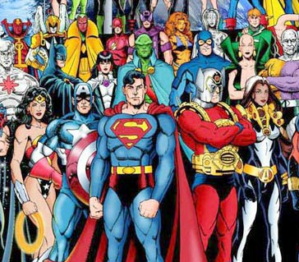

**Superhero Research**

Name:

Information that you **must include** on your poster:

|  |  |
| --- | --- |
| **Criteria** | **Fill in or use a tick mark to indicate this is complete** |
| A **creative drawing** of your superhero (coloured) |  |
| **Superhero’s name** (ex. Kryptonic Man) |  |
| A **slogan** for your superhero that is related to a characteristic of you element (ex. Kryptonic Man – *“The Noblest of the Superheroes”)* | “ ” |
| **Element symbol** |  |
| Source: | |
| **Atomic number** |  |
| Source: | |
| **Atomic mass** |  |
| Source | |
| **Group/family name or number** |  |
| Source: | |
| **Period number** |  |
| Source: | |
| **Bohr model** |  |
| Source: | |
| **Variety of uses** of the element (what will the superhero be able to do with these uses)  -as well, find real life pics of the element (minimum of 3) |  |
| Sources: | |
| **Background information**  ***Parents*** - the person who discovered the element  ***Birthdate*** – when it was discovered  ***Family Tree*** – name the members of the element's family or group  ***Metal or non-metal*** |  |
| Sources: | |
| **Physical** properties  -2 quantitative and 2 qualitative properties |  |
| Sources: | |

**Story**

Write a story about your superhero's powers and how he or she will use them. State at least 2-3 ways they use their powers. You can also include their background story on how they became a superhero. Don't forget to include your story on your poster.