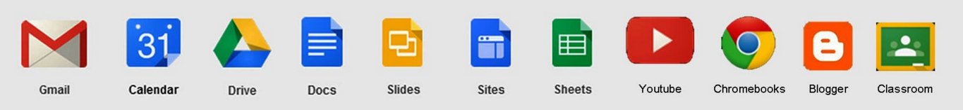

Part 1 - Google Apps for Education Login Procedure

Initial Sign-In

- Open Google Chrome browser
- Search for myaccount.google.com OR go to gmail.com
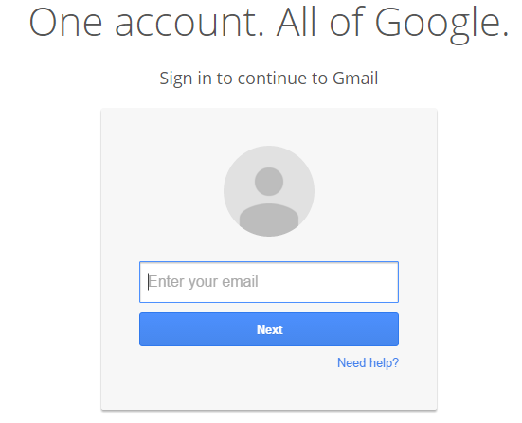
- Sign into your SD23 GAFE account. Your email username is: first.last.stu@learn.sd23.bc.ca

- Your initial password is Learn#23
- You will be able to change your password to your usual secure password once you have entered the information in steps 2 and 4
- Your password must be at least 8 characters long
- If a username is already filled in, you will need to sign in to a different account
- Click Sign in with a different account
- If you see a page describing Gmail instead of the sign-in page…
- Click Sign in in the top-right corner of the page

Sign-in Process

- After the initial sign-in, you will need to sign into your Google Chrome account each time (top right corner after you open the Google Chrome browser).
- 2 ways to sign-in to Google Chrome Gmail or Sign In
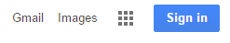

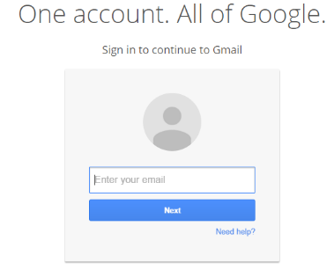
  - Either will get you to the sign in pop-up
  - Email address is: first.last.stu@learn.sd23.bc.ca

Part 2 – Signing Into a Specific Google Classroom

It is very quick and easy to set up. To sign-up for a specific Google Classroom, you will self-enroll in the specified classroom.

Student Self-Enrolment

- Sign in to Classroom classroom.google.com
- On the Home page choose "I am a Student"
- Click + sign
- Enter the unique class code provided and click Join

Part 3 – Features of the Google Apps for Education and Google Classroom

Google Classroom works side-by-side with Google Drive. Google Classroom is not a learning management system, student information system, or gradebook.

Gmail Account
- Some assignments might be emailed to your Gmail account. To get to Gmail:
- Click on the word "Mail" next to your username at the top right of the webpage
- Click on the Apps grid located beside your username in the top right side and then select click on Gmail

Classroom Stream
The Google Classroom Stream allows teachers to post assignments, add announcements, and share documents through the class Google Drive folder. There is also the ability to grade assignments and to provide student feedback.
- To add an item to the classroom stream simply select the + sign at the bottom right of the stream page.

Google Drive
This is where some assignments will be posted and shared. To get there:
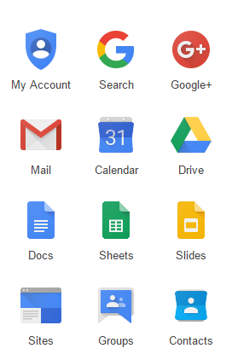
- Open Google Chrome browser
- Open your Gmail, then go to the Apps grid
- OR click on the Apps grid located beside your username in the top right side and then select click on Drive (or any other App).

